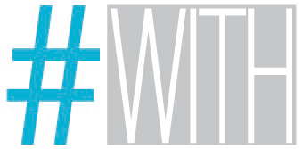

Contest #WITH – design WITH food

_Presentation

Promote Design announces the contest #WITH – design WITH food, open to all designers. Subject: “A designer and his relationship with food”, wants to tell personal stories with food, (artistic) inspirations, visions, suggestions, towards sustainability. Not only atrend, not only sensory perceptions of the taste that create well-being, but also a reflection on nutrition as one’s health.

_Participation/Attendance

Participation is free and it’s open to Italian e foreign designers (food, product, graphic, fashion, textile, interior, light). Designer groups are also welcomed, represented by a leader that will be the only responsible and representative towards Promote Design. Designers are asked to submit pictures, sketches representing a product, an icon, a material, an environment, a place, a trip or a sensory experience. As an example the content of the images may be an instrument ( inedited or not) to taste and/or prepare food, table accessories, a packaging for the transport and the conservation, shooting of a place linked to feeding someone and a way of eating.
In the case of controversy on the originality/authorship of the products, the designer will be the only responsible. The participation implies full acceptance of this announcement. Attending the competition, the participant agrees to the processing of personal data pursuant to Legislative Decree no. 196/2003. Promote Design is responsible for the data processing.

_Enrollment and terms of participation

All the participants at the contest must enroll no later than midnight on March 17, 2014, sending an e-mail at following address: with@promotedesign.it with name, last name and job and enclosing final projects. In case of projects with more of 5 Mb, it is recommended to use We Transfer or similar services.
All the projects must be submitted through images (pictures, sketches, renderings, graphics) strictly in jpg format, 300dpi and 4961x3508 pixels.
In addiction to the image, it must be attached a text file containing a payoff, maximum 120 characters (spaces included) and a project description, maximum 400 characters (spaces included).

_Evaluation Criteria

Originality, eco-friendly, ethical, accessibility and affinity to the theme of the competition will be the main criteria in the selection. A jury composed by Paul Barichella (Food designer), Enzo Carbone (Founder of promotedesign.it), Riccardo Chiozzotto (Journalist) will select the ideas according to the above-written criteria.

_Deadline

All the projects must be sent to with@promotedesign.it no later than midnight on march 17, 2014. Promote Design will announce the winners by 26 marzo 2014.
On Saturday 12th of April from 5pm to 8pm in the area dedicated to the event Din – Design In, in Via Massimiano 6, Milan, a committe chaired by Food designer Paolo Barichella, will introduce the three winners of the contest.

_Awards

The top 3 winners will see the picture of their project printed and exhibited at the event din 2014, one of the most important event taking place during the Fuorisalone (April 8 to 13 in 2014) in via Maximian, 6 (Lambrate) in Milan. Another 20 pictures selected by the jury will be part of a digital exhibition that will take place during the exhibition din2014.

_Notes

Participants do authorize promotedesign.it to publish the submitted material and make it accessible to the public. This option is for free in order to produce paper and digital materials, videos, exhibitions, etc.. Any further informations about the participation in the competition can be requested by email: with@promotedesign.it or by phone: 02/PROTECTED.

The participant declares, that he is liable for the exclusive concept of the projects being published and is the only responsible for the material posted and avoid the organization from every liability relating to the ownership of the Project and the possible violation of industrial or intellectual property of third, determined by content submitted from the participant to the organization.

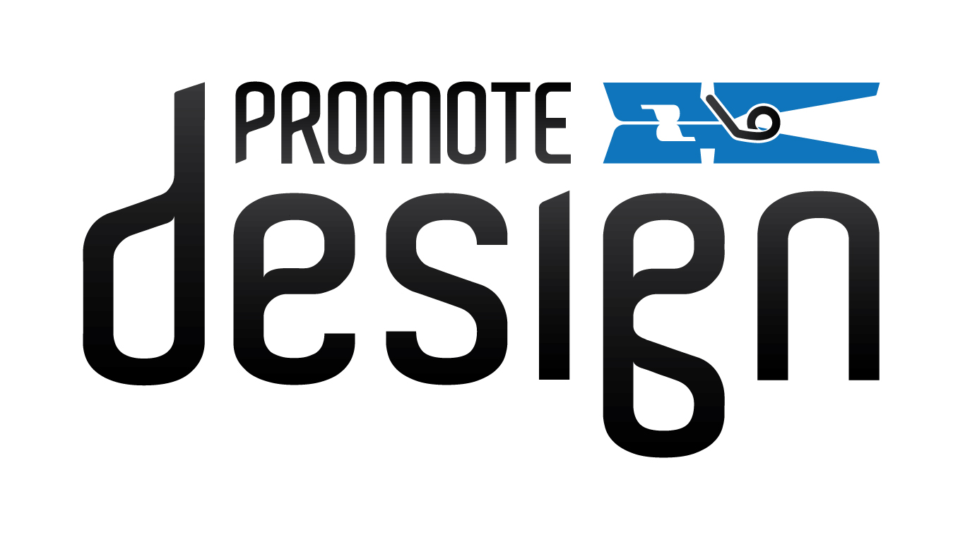

Din Partnership:

